# Software Requirements Specification

Table of Contents

Table of Contents i-iv

Revision History iv

1. Introduction 5

1.1 Purpose 5

1.2 Document Conventions 5

1.3 Intended Audience and Reading Suggestions 5

1.4 Product Scope 5

1.5 References 5

2. Overall Description 5

2.1 Product Perspective 5

2.2 Product Functions 5

2.3 User Classes and Characteristics 5

2.4 Operating Environment 5

2.5 Design and Implementation Constraints 6

3. External Interface Requirements 7

3.1 User Interfaces 7

3.2 Hardware Interfaces 7

3.3 Software Interfaces 7

3.4 Communications Interfaces 7

4. System Features 8

4.1.Room Cleaning 8

4.2.Laundry Services 9

4.3.Create Profile………………………………………………………………………………9

Use case Diagram……………………………………………………………………….........10

4.4.Update Profile…………………………………………………………………………….11

4.5.Register…………………………………………………………………………………12

4.6.Job Search……………………………………………………………………………….13

4.7.Give feedback…………………………………………………………………………….13

4.8.Handle visit care applications……………………………………………………………14

4.9.Post Job vacancies………………………………………………………………………15

4.10.Allot maid timings………………………………………………………………………16

4.11.Handle Feedback………………………………………………………………………..16

4.12.Contact for visit care…………………………………………………………………….17

4.13.Login…………………………………………………………………………………….18

4.14.Authentication…………………………………………………………………………..18

5. Other Nonfunctional Requirements 19

5.1 Performance Requirements 19

5.2 Security Requirements 19

5.3 Software Quality Attributes 19

5.3.1.Reliability………………………………………………………………………………………20

5.3.2.Maintainability…………………………………………………………………………..20

5.3.3.Portability………………………………………………………………………………..20

5.3.4.Reusability………………………………………………………………………………20

5.3.5.Flexibility………………………………………………………………………………..20

5.3.6.Resource utilization……………………………………………………………………..20

6. Other Requirements 21

Appendix A: Glossary 21

**Software Design Document**

1. **Introduction...................................................................................** 21

1.1 Purpose of this document ................................. 21

* 1. Scope of the development project ..........................21
  2. Definitions, acronyms, and abbreviations ...............22
  3. References .............................................................22
  4. Overview of document ........................................... 22

1. **Conceptual Architecture/Architecture Diagram ........................ 23**

2.1 User interface issues .................................................. 2**3**

# 3. Logical Architecture (Sequence Diagram, State Diagram)……23

**Sequence Diagrams.................................................. 24**

Home Page.....................................................................24

About Page..................................................................... 25

Feedback........................................................................ 26

Maid Profile..................................................................... 27

Employee Profile............................................................28

Work Allotted................................................................... 29

Visit Care......................................................... ………….30

**State Diagrams**

Visitor Account Page ....................................................... 31

Employee Account page ................................................. 32

Admin Account page ....................................................... 33

Admin post vacancies................................................ …..34

Admin about page.................................................. ……..34

**3.1 Logical Architecture Design** ...................................34

**3.1.1Sequence Diagrams ..............................................34**

3.1.1.1 Home page .......................................................... 35

3.1.1.2 About page ........................................................... 35

3.1.1.3 Feedback ......................................................... …35

3.1.1.4 Maid Profile .......................................................... 35

3.1.1.5 Employee Profile…………………………………….35

3.1.1.6 Work allotted………………………………………….35

3.1.1.7 Visit Care………………………………………………35

**3.1.2 State Diagrams…………………………………………35**

3.1.2.1 Visitor Account Page…………………………………36

3.1.2.2 Employee Account Page…………………………….36

3.1.2.3 Admin account page………………………………….36

3.1.2.4 Admin post vacancies…………………………………36

3.1.2.5 Admin about page………………………………………36

**3.2 Class name: View Profile()………………………………..36**

**3.3 Class name: About…………………………………………37**

**3.4 Class name: Home………………………………………….37**

**3.5 Class name: Contact………………………………………..37**

**3.6 Class name: Login………………………………………….37**

**3.7 Class name:Logout…………………………………………38**

**3.8 Class name: Create profile………………………………..38**

**3.9 Class name:Register……………………………………….38**

**4.0 Execution Architecture ..................................................38**

**4.1 Reuse and relationships to other products .................38**

**5.0 Pseudo code………………………………………………….38**

Class name:Login………………………………………………..38

Class name: Logout……………………………………………..39

Class name: View Profile……………………………………….40

Class name: Register……………………………………………41

**Minutes Of Meeting…………………………………………….42**

**Novelty of the Project………………………………………….43**

**Sophistication of the Project………………………………….44**

**Tools and Technologies used…………………………………44**

**Software Testing………………………………………………..45**

**Applicability of the project…………………………………….52**

**Coding Metrics…………………………………………………..53**

Revision History

|  |  |  |  |
| --- | --- | --- | --- |
| **Name** | **Date** | **Reason For Changes** | **Version** |
| **Housekeeping site** | 30 aug ,18 | Basic site is prepared | Version 1.0 |
| **Housekeeping site** | Nov 1 2018 | Front end is done | Version 1.0 |

# 1. Introduction

## Purpose

This product is main for the better communication between the company and customers of their company. We brought many new features to this site so that the customer should not face any problem.

## Document Conventions

In this document every requirement statement is to have its own priority.

## Intended Audience and Reading Suggestions

This document is intended for mainly for developers of website of same concept and purpose. This document will also help those who are starting new and can be a perfect guide for their own project. As given in the Table of Contents that order will be followed by this document. Before reading this document have a brief knowledge about the purpose of this document.

## Product Scope

The main scope of this project is for a better communication between the customer and the company. We got many features which will make easy for customer to contact the company through the website. We are also having a feature which is called as “Visiting care” , where we can call up and get them home for small works like shifting and cleaning houses. As it is gonna be a technological world In future this type of connection with the customers will help this company a lot.

## References

While making this website we had taken few information from many websites or vision and scope documents, as there are many which I cant give any reference in this SRS.

# Overall Description

## Product Perspective

1. client/server system
2. Operating system: Windows.
3. database: sql+ database platform
4. HTML/Java/PHP

There is this company named Rao’s facilities basically a housekeeping managing company. We decided to work on the site for this company so that it willn also be helpful for the company for it’s publicity.This is a self-conatined product.

## Product Functions

The features involved in this are :

* 1.this will have a basic contact info about the company and also about the company.
* 2.It allows the users to register their various types of profiles like social, personal and professional for ease of communications.
* 3.Based on the vacancies in the company ,one can even apply for a job if needed. This can also improve the job opportunities and makes the job search easy.
* 4.VISIT CARE. Here the customer can contact the company through this site for small works to be done. This contract will be made for a required period of time.
* 5.We can also download brouchers and also request a call back.
* There is this feature chat where the customers can talk to the members of the company which makes the work easier and also let the customer get rid of all the queries if any

## User Classes and Characteristics

The most frequent users of this site will be the public and the members of the company itself. The website will be updated with time . The modifications required for the site will be managed by the admin.

## Operating Environment

The operating environment for the housekeeping management site are:

1. Distributed database

2. Client/server system

3. Operating system: Windows.

4. Database: sql+ database

5. Platform: HTML/Java/PHP

## Design and Implementation Constraints

1. The global schema, fragmentation schema, and allocation schema.
2. SQL commands for above queries/applications
3. Assuming these are global queries. Explain how various fragments will be combined to do so.
4. Implement the database at least using a centralized database management system.

# External Interface Requirements

## User Interfaces

In user Interface there are mainly two ends

1. Front end – Css 3 is used for the front end and few codes of java script for animations.
2. Back end – and in the back end we use HTML, database + SQL.

## Hardware Interfaces

In this the hardware Interfaces used are

1. Windows / Ubuntu of any version.
2. A browser which supports CGI, HTML & JavaScript.

## Software Interfaces

Following are the software used for the facility management online application.

|  |  |
| --- | --- |
| **SOFTWARE USED** | **DESCRIPTION** |
| Operating System | We have chosen Windows operating system for its best support and user-friendliness. |
| Database | To save the information like address and the details of their mail address and the applications send by the people who applied for job , we used the database. |
| Html | To implement the project we have used HTML language for its more interactive support |

## Communications Interfaces

This project supports all types of web browsers. We are using simple electronic forms for the job application, request a visit from the company etc.

# System Features

1. Automation and real-time updates towards room cleaning information
2. Voice-assisted rooms using local phones
3. Real-time status for completed task by housekeeper

**Pre-Condition**: For all the use cases, it is the pre-condition that the user is logged into the system**.**

## Room cleaning

4.1.1 **Description and Priority**

Room cleaning is a part of house keeping which should be taken care of.It is

done by maid. This will be given higher priority and is treated an essential part

of house keeping.

4.1.2 **Stimulus/Response Sequences**

1. Employee allots particular time slots for maids with some partiticular tasks.

Some of them will be given room cleaning.

2. Maids who are allotted slots for this purpose will clean the room in the

Respective timings .

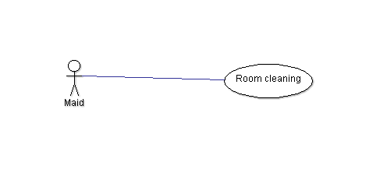

**4.2 Laundry Services**

4.2.1 **Description and Priority**

It is an essential part of house keeping. Wasing clothes and changing the

Bedsheets come under this.

4.2.2 **Stimulus/Response Sequences**

1. Maids have an acces to check the work allotted to them .

2. Accordingly the maids allotted slots for laundry services will handle these.

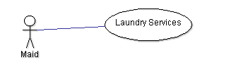

**4.3 Create Profile**

4.3.1 **Description and Priority**

This option provides the facility for updating the profiles of the users. This is

an optional feature.

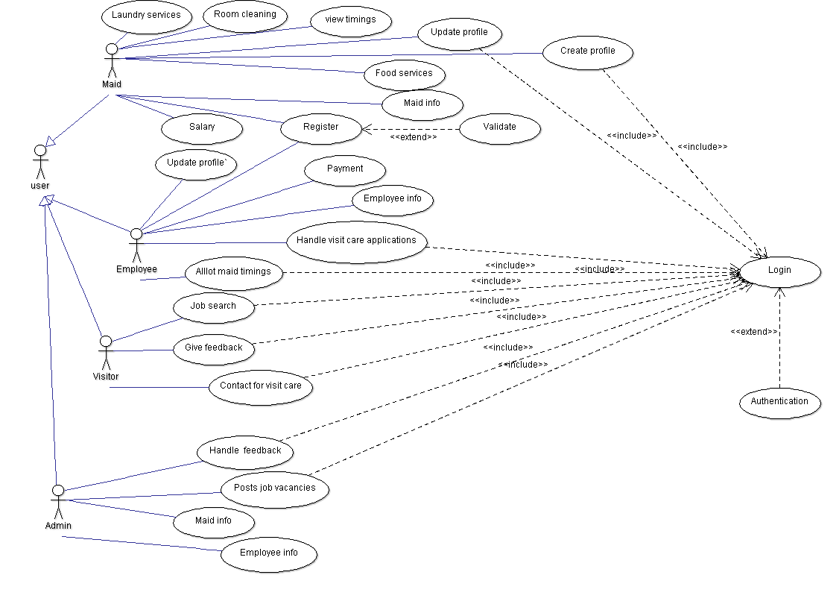

4.3.2 **Stimulus/Response Sequences**

The user who ever is interested in creating their own profile can access this

by clicking the create profile option. This is usually accessed by maids

and the Employees.

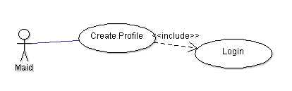

**4.4 Update profile**

4.4.1 **Description and Priority**

The user using this site can update their own profile that may be useful for

applying the job or can also be done by the persons already working in the

company. This is necessary for the people applying for the job.

4.4.2 **Stimulus/Response Sequences**

This option will be available only after a user creates his/her profile. If the

user wants to make any changes regarding his/her profile then will click on

update profile and then can make the necessary changes.

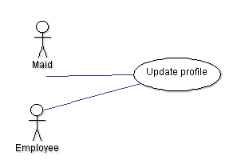

**4.5 Register**

4.5.1 **Description and Priority**

Register is different from login. Registration only happens the first time you

access the system.

4.5.2 **Stimulus/Response Sequences**

Once a user registers with the site he/she can access only a few features like

they can create their own profile.

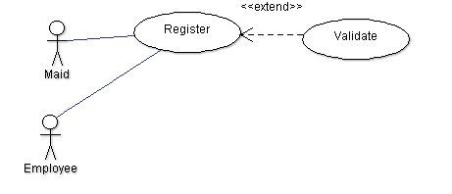

**4.6 Job Search**

4.6.1 **Description and Priority**

Through this feature any user can search for a job if required. This can be

accessed by visitors.

4.6.2 **Stimulus/Response Sequences**

1. The user logins into the site

2. If in need of a job they can see the vacancies available by clicking on jobs.

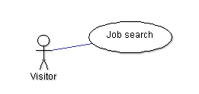

**4.7 Give Feedback**

4.7.1 **Description and Priority**

This is related to the work done by the maids. The customers are required to

give the feedback based on their performance. This is essential as it can bring

improvement in the work done by the maids. This feedback can also be given

by the visitors who contact the company for maids for their household work

based on a contract.

4.7.2 **Stimulus/Response Sequences**

1. The maid does the work that is allotted to her.

2. The customers give the feedback based on her performance.

3. If the work of the maid is not satisfactory she will need to improve herself in

that as per the feedback provided.

4. If the maid gets a good feedback there may be chances of her salary

increment.

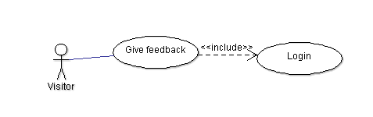

**4.8 Handle visit care applications**

4.8.1 **Description and Priority**

Visit care is the facility provided by the company through which people who are

busy and do not have the time to clean their house can appoint maids based on

contract for a minimum of 6 months. These applications are handled by the

employees.

4.8.2 **Stimulus/Response Sequences**

1. The person who is in need of a maid to clean the house will place an

application through the site.

2. The person must agree with the terms and conditions of the company.

3. The payment demanded by the company must be paid by the person.

4. If both agree to each others terms and conditions a contract is made . This

takes place between the employee and the customer.

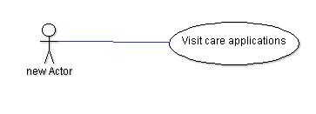

**4.9 Post job vacancies**

4.9.1 **Description and Priority**

If the company is need of maids then it advertises saying that there are

vacancies for the job of a maid.This is considered as less priority unless the

company is in very bad need of maids.

4.9.2 **Stimulus/Response Sequences**

1. If there is a need for maids the admin posts the job vacancies.

2. The visitors who are in search of job apply for it.

3. If they accept the terms and conditions of the compay they are given a job.

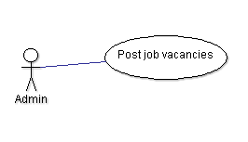

**4.10 Allot Maid timings**

4.10.1 **Description and Priority**

The whole work is divided between the maids as some of them are allotted

room cleaning some of them are allotted laundry services and some are

allotted food services. They are allotted specific timings for this. This has a

higher priority as it reduces clashes in the timings.It is done by employees.

4.10.2 **Stimulus/Response Sequences**

1. Maids are allotted a category of work.

2. They are allotted specific timings for doing that work.

3. These timings can be viewed by the maids and the work is done accordingly.

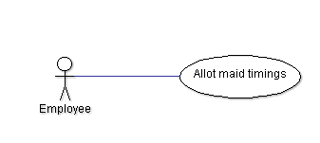

**4.11 Handle Feedback**

4.11.1 **Description and Priority**

The feedback given by the customers will be handled by the admin.

4.11.2 **Stimulus/Response Sequences**

1.Feedback is given by the customers

2. The admin can view all the feedbacks.

3. The maids are given the feedback they received so as to improve their

performance.

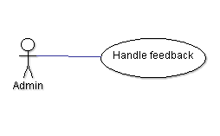

**4.12 Contact for visit care**

4.12.1 **Description and Priority**

The customers can contact the company if they need maids for their household

work through this facility.

4.12.2 **Stimulus/Response Sequences**

1. The customer fills the application accepting the terms and conditions.

2. A contract is made between the company and customer.

3. Maids are sent for work.

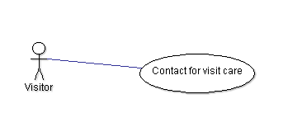

**4.13 Login**

4.13.1 **Description and Priority**

 Every time after your initial registration, you will log on to the system using

the username and password you created.

4.13.2 **Stimulus/Response Sequences**

Activities like creating profile, allot maid timings,job search etc require login.

This can be done with a username and password or can be done by usind mail.

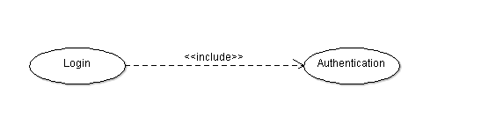

**4.14 Authentication**

4.14.1 **Description and Priority**

The process or action of verifying the identity of a user or process. This is an

Extension to login.

4.14.2 **Stimulus/Response Sequences**

Once the user logins then the username and password is verified if they are

correct. If they are correct he will be given access.



# Other Nonfunctional Requirements

## Performance Requirements

## The system is to perform at the same speed, co-operate in the same memory and require normalized disk utilization as that of a commercially available office productivity application software product. Currently these requirements range as such: 300 – 700 MHz CPU, 32 – 128 MB DRAM and .2 – 20 GB of permanent disk storageSafety Requirements.

## Security Requirements

There will be a separate login which can be accessed using either gmail or facebook.

This will be unique for every user..Until and unless these details are shared to anyone by the user there will be no issue.

## Software Quality Attributes

The Additional quality characteristics for the product that are important to either the customers or the developers are adaptability, availability, correctness, flexibility, interoperability, maintainability, portability, reliability, reusability, robustness, testability, and usability. By these qualities the usage of the product and as well as developing product will be easy.

## 5.3.1.Reliability

The system must provide all functionality whenever in use. System crashes are not to impair the data. System crashes are not to impair the system.

## 

## 5.3.2.Maintainability

The system is to be maintained entirely by the end user after delivery

**5.3.3.Portability**

It is made such that it can be used in operating systems other than the one in which it was created.I

## 5.3.4.Reusability

The system components must be reusable for the current and future versions of this product. Development reusability within the development organization is not necessary.

**5.3.5.Flexibility**

It is to be made such that it will adopt to any kind of changes in the future.

## 5.3.6. Resource Utilization

The system should be limited to the resources normally allocated to a commercially available PC application product

# 

# 6. Other Requirements

There are few requirements like database requirements etc.

Appendix A: Glossary

**company head** - Member of the Hospitality company , by whom the whole company works.

**Super manager**- Member of the Hospitality company who works as a company head Assistant.

**Python and Django Framework.**

**Functional Requirements -** A detailed list of all the services provided by the system.

**Customer -** A person who visits the Hospitality website for booking a home visit or download the brochure and various features.

**Software Design Specification**

# 1. Introduction

The Software Design Document is a document to provide do cumentation which will be used to aid in software development by providing the details for how the software should be built. Within the Software Design Document are narrative and graphical documentation of the software design for the project including use case models, sequence diagrams, collaboration models, object behavior models, and other supporting requirement information.

## 1.1 Purpose of this document

This document will define the design of the one runway simulator. It contains specific information about the expected input,output,classes and functions. The interaction between the classes to meet the desired requirements are outlined in detailed figures at the end of the document.

## 1.2 Scope of the development project

We describe what features are in the scope of the software and what are not in the scope of the software to be developed.

In Scope:

1. Application for the job/internship by the any person of respective place.
2. Customer can retrieve the information about the particular services.

.

Out of Scope:

a. Selection process for any internship

## 1.3 Definitions, acronyms, and abbreviations

IEEE: Institute of Electrical and Electronics Engineers

SDS: Software Design Specification

## 1.4 References

**1.4.1** R. S. Pressman, Software Engineering: A Practioner’s Approach, 5th Ed, McGraw-Hill, 2001.

**1.4.2** IEEE SDS template

## 1.5 Overview of document

This SDS is divided into seven sections with various sub-sections. The sections of the Software Design Document are:

1. **Introduction**: describes about the document, purpose, scope of development project definitions and abbreviations used in the document.
2. **Conceptual** **Architecture**/**Architecture** **Diagram:** describes the overview of components, modules, structure and relationships and user interface issues.
3. **Logical** **Architecture:** describesLogical Architecture Description and Components.
4. **Execution** **Architecture:** definesthe runtime environment, processes, deployment view.
5. **Design** **Decisions** **and** **Trade-offs:** describes the decisions taken along with the reason as to why they were chosen over other alternatives.

**2 .Conceptual Architectural Designs**

**2.1 User interface issues**

This section will address user interface issues as they apply to the following hypothetical users of this housekeeping services system.

1. User A is a 21-year old female who is fairly comfortable with technology. She is proficient with using the most common computer website applications.Since user A is familiar with android applications, this website will use common user interface conventions.For example, liks between screens will use ordinary , easy to understand descriptions such as :login”, “home”, “upload”,”CV”, “about” etc. To maintain consistency , any other links will also appear in the bottom half of the screen.

2. User B is a 35-year old male. He is although comfortable using online website applications, he has never used any portal which helps applying for jobs/internships. He may or may not acknowledge if this website application is really helpful to apply for a job.Since user B is not fond of such a technology oriented, it is imperative that he be given clear on-screen directions. Consequently, the user interface has been tried to be such that grabs the attention of the user. It has been taken care that user should not consider this application as a burden to use. On-clicks task implementation has been done in the application so that the admin have an ease in communication with the company.Colour combination has been chosen.

**3.Logical Architecture (Sequence Diagram, State Diagram)**

**Sequence Diagram**

**Home page**

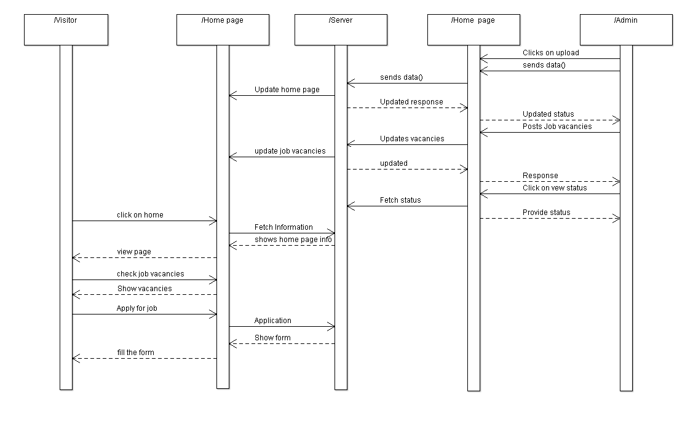

**About page**

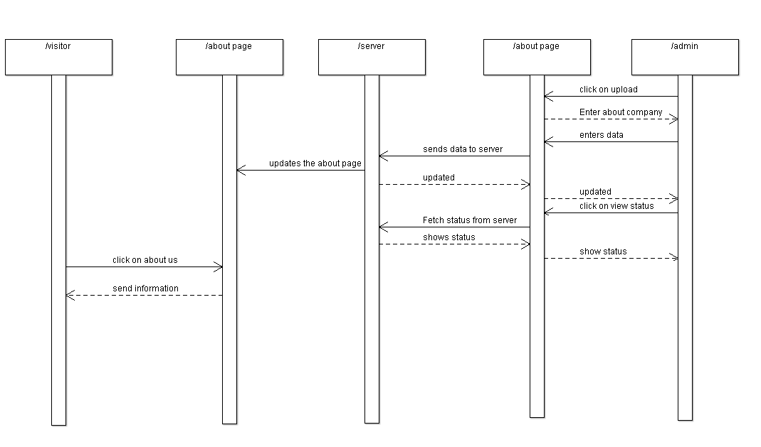

**Feedback**

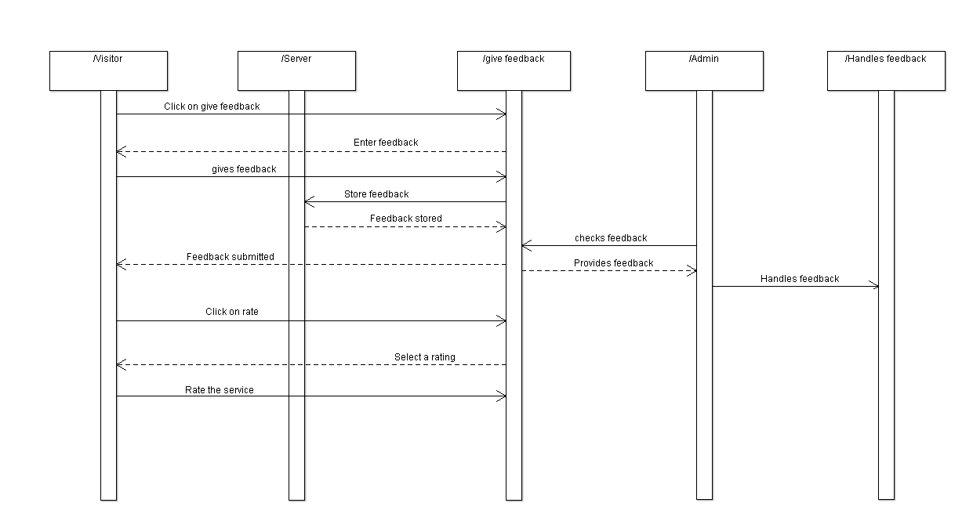

**Maid profile**

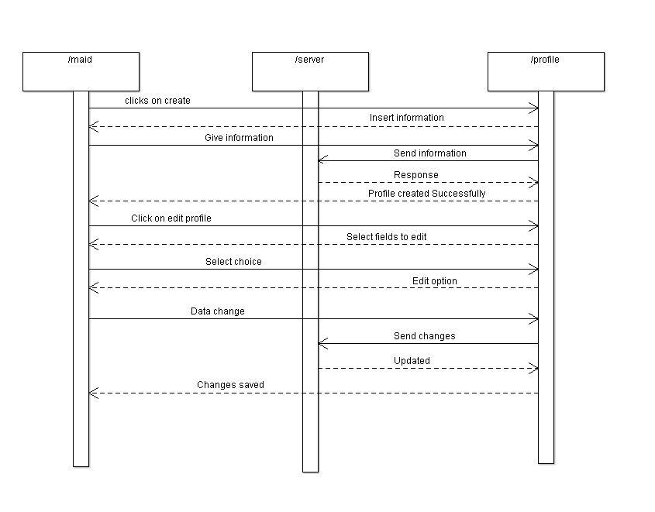

**Employee Profile**

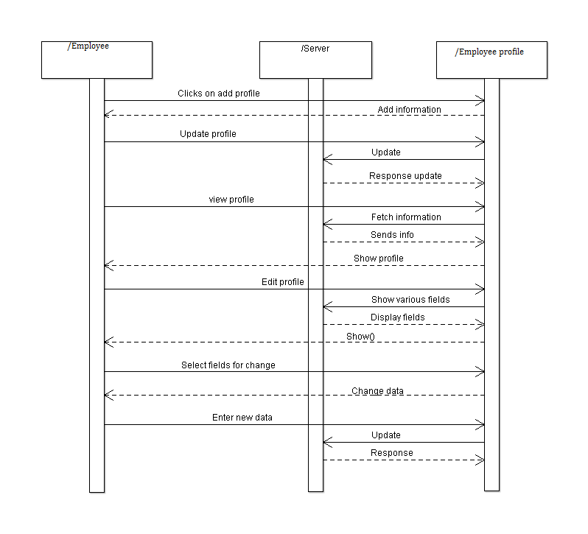

**Work allotted**

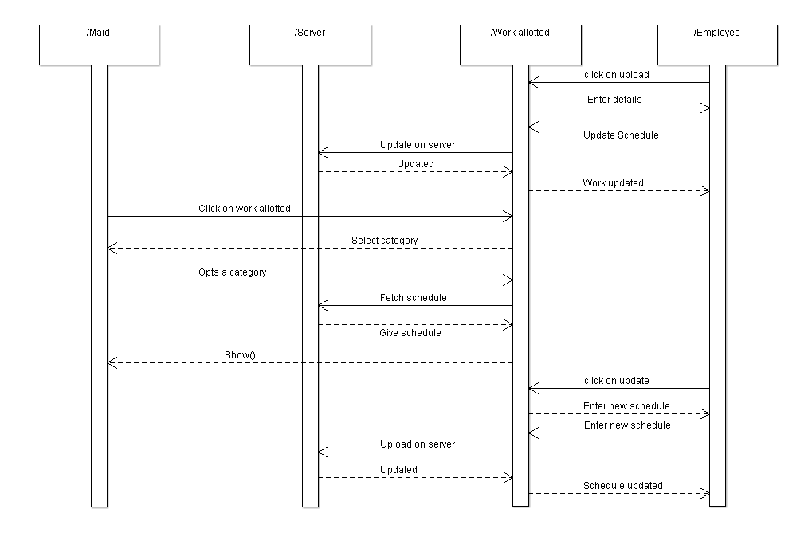

**Visit care**

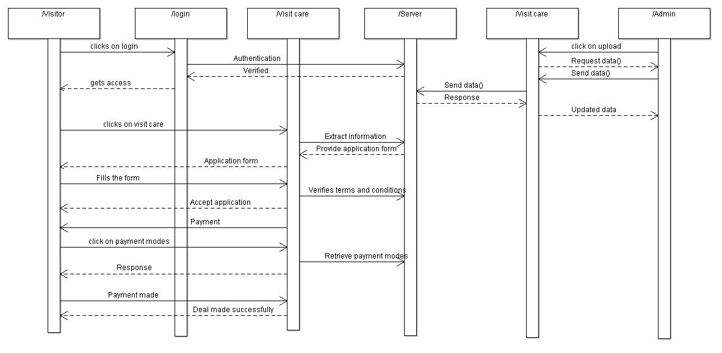

**State diagrams**

**Visitor account page**

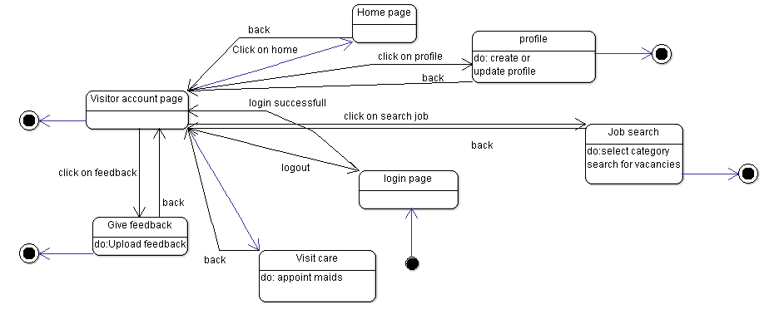

**Employee Account page**

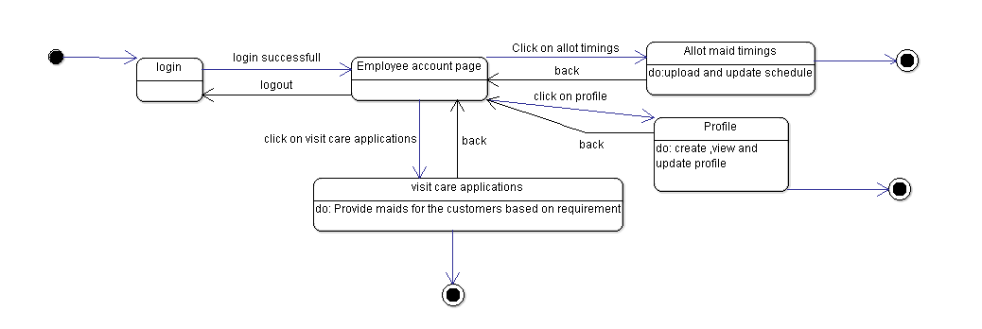

**Admin Account page**

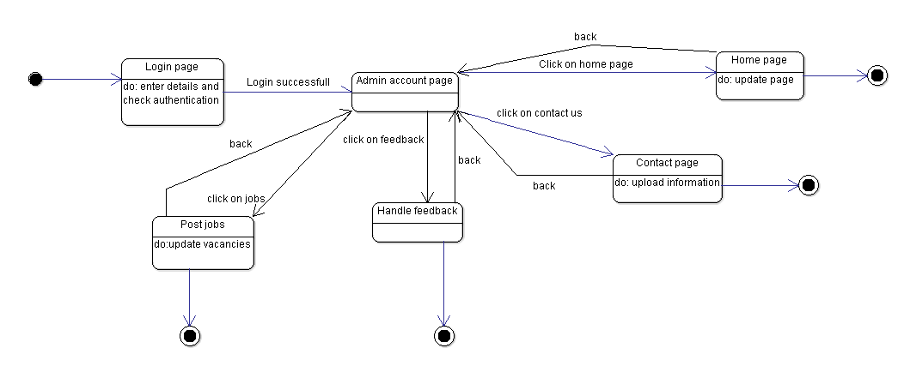

**Admin post vacancies**

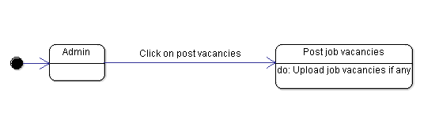

**Admin about page**

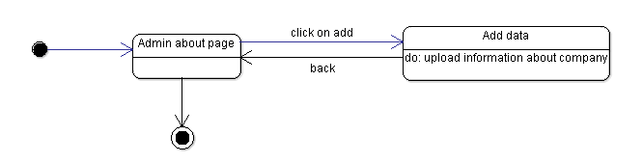

**3.1 Logical Architecture Description**

Sequence diagrams and state diagrams are drawn to depict the flow of actions related to the website.

**3.1.1 Sequence Diagram:**

In the Sequence diagram a role will be defined by a rectangular box , arrow represents a sent message and the response for that message is shown by dotted line.The messages with response are called synchronous messages.

**3.1.1.1 Home page**

Home page contains access to the about page ,contact page, it also provides an option for job search. This makes it easier for the visitors to search for the jobs they require.

**3.1.1.2 About page**

This page contains certain information regarding the company. This will be updated by the admin every time if necessary.Visitors , employees and maids will have access to this page.

**3.1.1.3 Feedback**

Feedback page provides an option for the customers who have contacted the company for visit care to give the feedback of the maids based on their work.

**3.1.1.4 Maid Profile**

The maids working for the company should have their profile created and up to date.They can access this profile page by logging in and clicking on create or edit profile option.

**3.1.1.5 Employee Profile**

The employees working for the company also have their profiles created. Employee have a separate login to their account and they have to create their profile and also keep it updated with time.

**3.1.1.6 Work allotted**

The maids working in the company will be allotted certain timings and separate slots for their work. The schedule of their work will be updated with time by the employees.

**3.1.1.7 Visit care**

This feature allows the customers to contact the company if they need maids for their household work. This will be a contract between the customer and the company for a certain period of time.These applications are handled by employees.

**3.1.2 State Diagram**

Intial state is being shown by starting with a black dot. Final state is being shown by the black dot surrounded by a circle. Do defines the operations that are to be done

**3.1.2.1 Visitor Account page**

Initially a login is required to be done by the visitors in order to access some of the features of the website. After logging into the website by entering the credentials he can access various features like create or update profile, job search, can access the home page

**3.1.2.2 Employee Account Page**

After logging in to the website using the correct credentials an employee can have access to some features like allot maid timings , can upload or update profile, and also handles the visit care applications.

**3.1.2.3 Admin Account page**

Admin is the one who has access to all the features of the website. He can login using the credentials and also have the access to check for the authentication.. He posts the job vacancies which can be viewed by the visitors, Updates the contact page, updates the home page and also handles the feedback.

**3.1.2.4 Admin post vacancies**

Admin posts the job vacancies so that people who are in need of the jobs can access the website and search for jobs in their selected category by logging into the website.

**3.1.2.5 Admin About page**

In the about page the admin enters the data regarding the company by clicking on add button and upload the information.

**3.2 Class name: View Profile()**

Description:

1. When the user clicks on the view profile button, it redirects the user to the profile page.

2. This will show the information related to the profile of the person accessing the site.

**3.3 Class name: About**

Description:

1. Click on the about button to access the about page.

2. This gives the information present on the about page which is updated by the admin.

**3.4 Class name: Home**

Description:

1.By clicking on the home button we can access the home page of the website.

2.This page provides access to about page, contact page .Job search is the option that is available in the home page that allows people to apply for jobs if necessary.

**3.5 Class name: Contact**

Description:

1. Contact page can be accessed by clicking on contact us in the home page.

2. Contact page contains the details of the company through which a user can get in contact with the company.

**3.6 Class name: Login**

Description:

A user is required to login into the website before he can access all of its features. Login involves authentication where a user enters his username or email and his password. Then if the given details are correct the user can login successfully and goes to home page. Or else he will be again redirected to the login page.

**3.7 Class name: Log out**

Description:

This is optional for a user to logout from their account. It can simply be accessed by clicking the logout or sign out button.

**3.8 Class name: Create Profile**

Description:

This option would be useful for maids as well as employees working for the company. The user enters the necessary details to create a profile and that would be successful.

**3.9 Class name: Register**

Description:

Registration only happens the first time you access the system.  It is a way to check your credentials.  Every time after your initial registration, you will log on to the system using the username and password you created

**4.0 Execution Architecture**

This is a website which requires active internet connection for working and also the system in which it is being used must be in a good working condition.

**4.1 Reuse and relationships to other products**

* NIL

**5.0 Pseudo code**

**Class name:Login**

1. import java.io.IOException;
2. import java.io.PrintWriter;
4. import javax.servlet.ServletException;
5. import javax.servlet.http.HttpServlet;
6. import javax.servlet.http.HttpServletRequest;
7. import javax.servlet.http.HttpServletResponse;
8. import javax.servlet.http.HttpSession;
9. public class LoginServlet extends HttpServlet {
10. protected void doPost(HttpServletRequest request, HttpServletResponse response)
11. throws ServletException, IOException {
12. response.setContentType("text/html");
13. PrintWriter out=response.getWriter();
14. request.getRequestDispatcher("link.html").include(request, response);
16. String name=request.getParameter("name");
17. String password=request.getParameter("password");
19. if(password.equals("admin123")){
20. out.print("Welcome, "+name);
21. HttpSession session=request.getSession();
22. session.setAttribute("name",name);
23. }
24. else{
25. out.print("Sorry, username or password error!");
26. request.getRequestDispatcher("login.html").include(request, response);
27. }
28. out.close();
29. }
30. }

**Class name: Logout**

1. import java.io.IOException;
2. import java.io.PrintWriter;
4. import javax.servlet.ServletException;
5. import javax.servlet.http.HttpServlet;
6. import javax.servlet.http.HttpServletRequest;
7. import javax.servlet.http.HttpServletResponse;
8. import javax.servlet.http.HttpSession;
9. public class LogoutServlet extends HttpServlet {
10. protected void doGet(HttpServletRequest request, HttpServletResponse response)
11. throws ServletException, IOException {
12. response.setContentType("text/html");
13. PrintWriter out=response.getWriter();
15. request.getRequestDispatcher("link.html").include(request, response);
17. HttpSession session=request.getSession();
18. session.invalidate();
20. out.print("You are successfully logged out!");
22. out.close();
23. }
24. }

**Class name: View profile**

1. import java.io.IOException;
2. import java.io.PrintWriter;
3. import javax.servlet.ServletException;
4. import javax.servlet.http.HttpServlet;
5. import javax.servlet.http.HttpServletRequest;
6. import javax.servlet.http.HttpServletResponse;
7. import javax.servlet.http.HttpSession;
8. public class ProfileServlet extends HttpServlet {
9. protected void doGet(HttpServletRequest request, HttpServletResponse response)
10. throws ServletException, IOException {
11. response.setContentType("text/html");
12. PrintWriter out=response.getWriter();
13. request.getRequestDispatcher("link.html").include(request, response);
15. HttpSession session=request.getSession(false);
16. if(session!=null){
17. String name=(String)session.getAttribute("name");
19. out.print("Hello, "+name+" Welcome to Profile");
20. }
21. else{
22. out.print("Please login first");
23. request.getRequestDispatcher("login.html").include(request, response);
24. }
25. out.close();
26. }
27. }

**Class name: Register**

1. import java.io.*;
2. import java.sql.*;
3. import javax.servlet.ServletException;
4. import javax.servlet.http.*;
6. public class Register extends HttpServlet {
7. public void doPost(HttpServletRequest request, HttpServletResponse response)
8. throws ServletException, IOException {
10. response.setContentType("text/html");
11. PrintWriter out = response.getWriter();
13. String n=request.getParameter("userName");
14. String p=request.getParameter("userPass");
15. String e=request.getParameter("userEmail");
16. String c=request.getParameter("userCountry");
18. try{
19. Class.forName("oracle.jdbc.driver.OracleDriver");
20. Connection con=DriverManager.getConnection(
21. "jdbc:oracle:thin:@localhost:1521:xe","system","oracle");
23. PreparedStatement ps=con.prepareStatement(
24. "insert into registeruser values(?,?,?,?)");
26. ps.setString(1,n);
27. ps.setString(2,p);
28. ps.setString(3,e);
29. ps.setString(4,c);
31. int i=ps.executeUpdate();
32. if(i>0)
33. out.print("You are successfully registered...");

36. }**catch** (Exception e2) {System.out.println(e2);}
38. out.close();
39. }
41. }

**Minutes Of Meeting with customer**

**Brief:** Purpose of this website is to make the communication between the customer and the company easy by making a medium of communication which is this website by letting the customer knowing the valuable information like real time charges for the services provided through company. We also added a new opportunity to the people who are seeking or jobs also by adding a new option where they can send resume and get a best job. Customer which are like household needs can request a onetime visit to the house and get their job done.

**Customer:** The main customer of this company are big companies who need their job of cleaning their surroundings done and as we added a new feature this can be used for people who are in need of job. This can be used by housing staying people too**.**

**Agenda:** To increase the communication between customer and the company.

**Conversations:**

All of our conversation between the company had been through phone.

On our **first conversation** we had on the design and the requirements of company and they want the website to be presented to outer world so that they use this website more easily without any difficulty.

On our **second conversation** we talked about the dead line and the progress of the work. At that time of the conversation we had just completed the first page of the website. They were happy with the work we had done so far. They were eagerly waiting for the end product of the website.

On our **third conversation** we couldn’t show any major result because of the exams we had and holidays. We gave assurance of the getting the job done in the given time. We also showed them the final design of the website and also had talked about adding more features to website in the given dead line.

**Suggestions:**

We had few suggestions on the features which should be added on the website and also on the work speed. We and a few suggestions on design part also.

**Novelty Of the Project**

This website is made in order to improve the facilities provided by a house keeping company named Rao’s Facility. It also decreases the gap between the customers and the company.

This website is made in order to make it much more easier for the people whoever are busy and could not get their household work done on time.This provides a feature called visit care. Through this option one can contact the company for maids for their household work to be done.It will also be helpful to the company to expand their business.

It can be said that this website will be a great use nowadays as people have become very busy not even being able to do their own work. Accessing a website would be a much easier job to do rather than going to the company or in search of maids.

The advantages of using this website would be:

1. Get their work done just by filling a simple application.

2. Get notified for any offers available.

3. Work done at low cost.

4. Simplifies the life of people nowadays.

In the business point of view it can be stated as follows:

1. Optimises business firms.

2. Helps in expanding their business.

The website is exceptional in its own specific manner. Any user can apply so that the company provides maids .

**Sophistication of the project**

This website is main for the better communication between the company and customers of their company. We brought many new features to this site so that the customer should not face any problem.

The difficulties faced during our website design are as follows:

**Technology relates issues:**

* Regarding the programming language to be used we faced a problem as we were not that good at coding. But somehow we managed to learn the language and have done it as a team.

**Time related issues:**

* Although we planned our time properly for this project it was difficult sometimes for all three of us make it happen. Now that there are exams we are trying our best to make time for it and complete this project.

**Research related issues:**

* At first when we thought of doing a website for this house keeping company we faced a situation while thinking of the features that must be put in this. We surfed the internet for information and finalized it.

Although we faced these issues and took a long time to design this website we stood as a team and have completed the project on time.

**Tools and Technologies used**

**Tools used for Specification phase:**  IEEE SRS Format, Argo UML for Use case diagrams

**Tools used for design Phase :** IEEE SDS Format, Argo UML for Sequence and State diagrams, Software design tools.

**Tools for assessment of code:** Jhawk (CK metrics),

**Tools for testing :** Android Studio Debugger, Android Studio Logcat Monitor

**Tools used for team collaboration :**GitHub

**Hardware Used :** Laptop

**Environment:** Windows

**Browser:** Chrome

**Productivity Tools :** Microsoft Word, Microsoft Excel, Adobe Pdf Reader.

**Software Testing**

**House Keeping Website**

**Home Page:** The work on home page is complete. Through this page one can access to any other page.

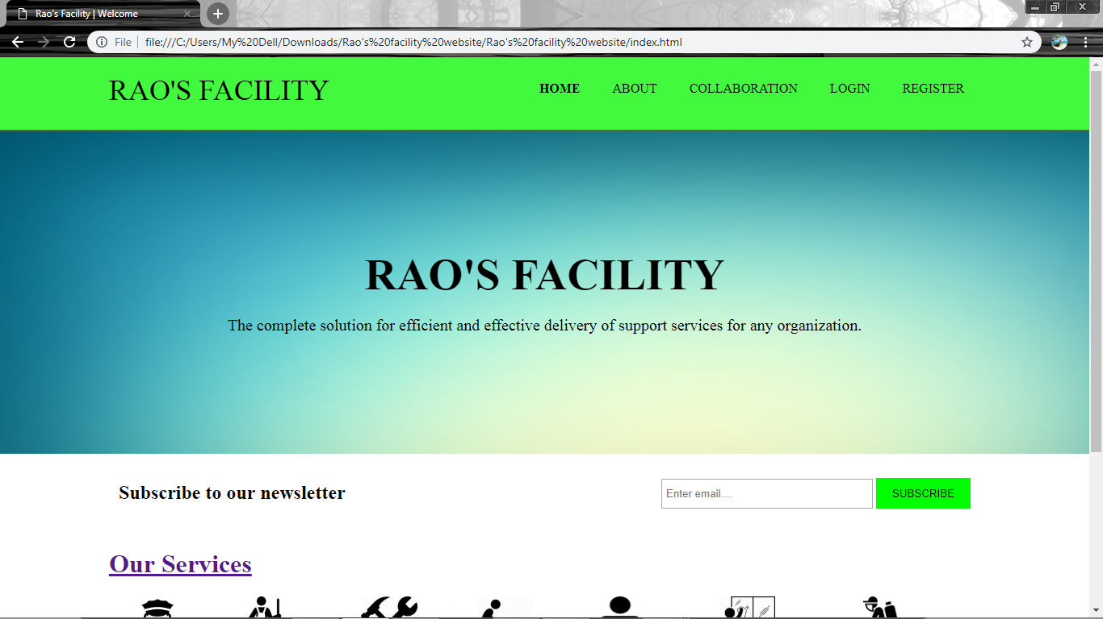

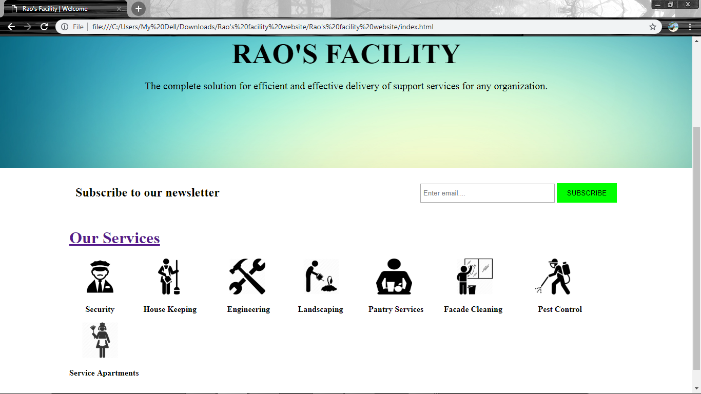

**About page:** More information regarding the company are to be added to this pages along with the images.

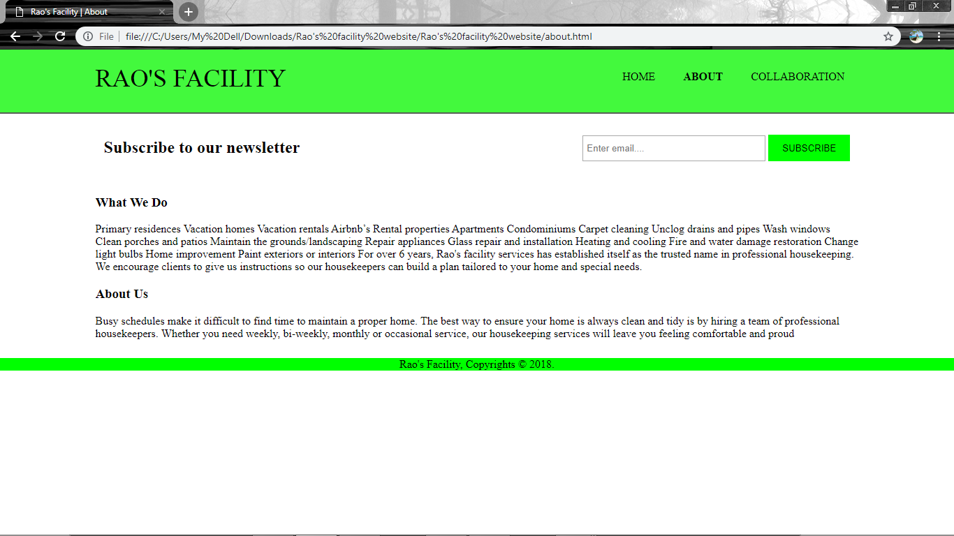

**Collaboration:** This page mainly describes the companies that are tied up to Rao’s facility. The page is not yet completed . The information regarding the companies is to be updated and will be done by the time of presentation of the project.

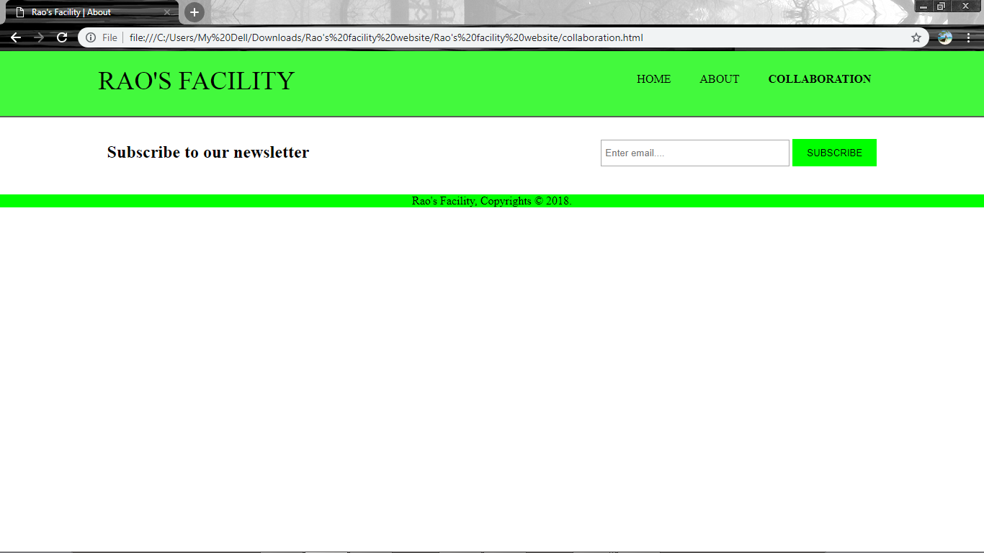

Our Services: This section includes the facilities that are provided by the company. The pages are not complete yet text is to be inserted.

* House Keeping
* Security
* Engineering
* Landscaping
* Pantry Services
* Façade Cleaning
* Service Apartments
* Pest control

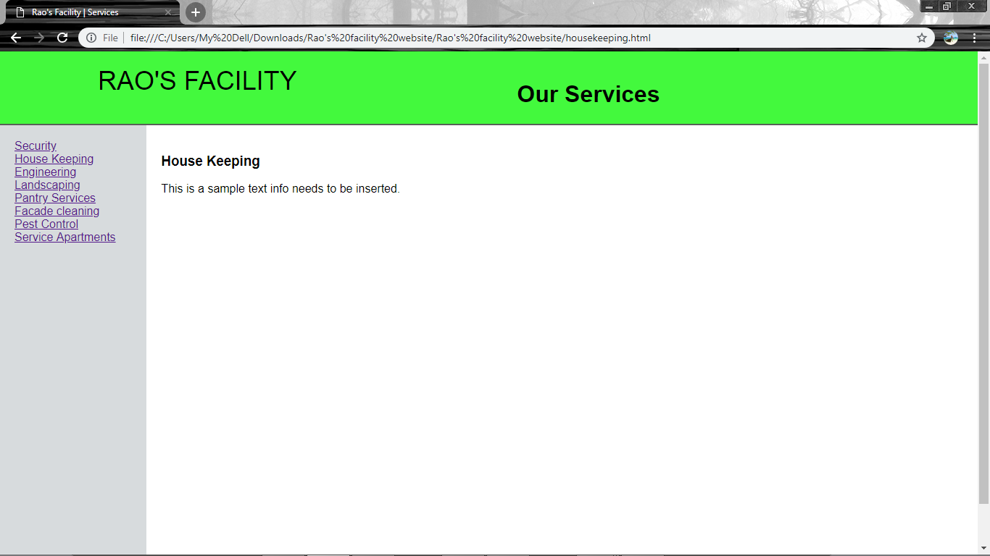

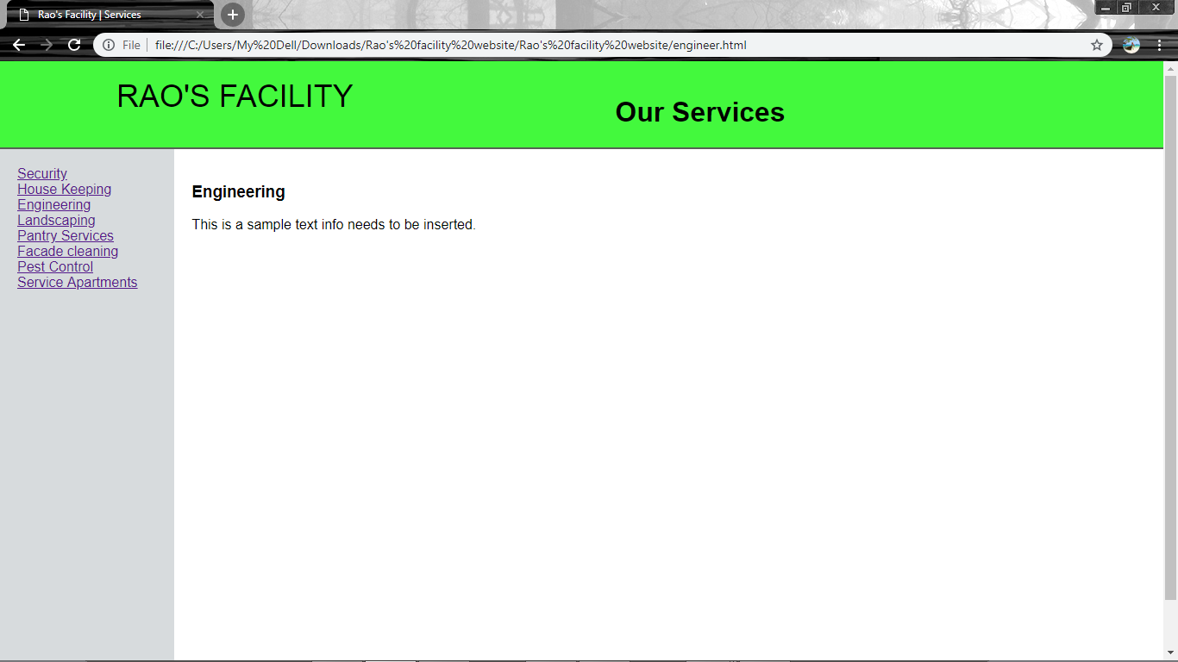

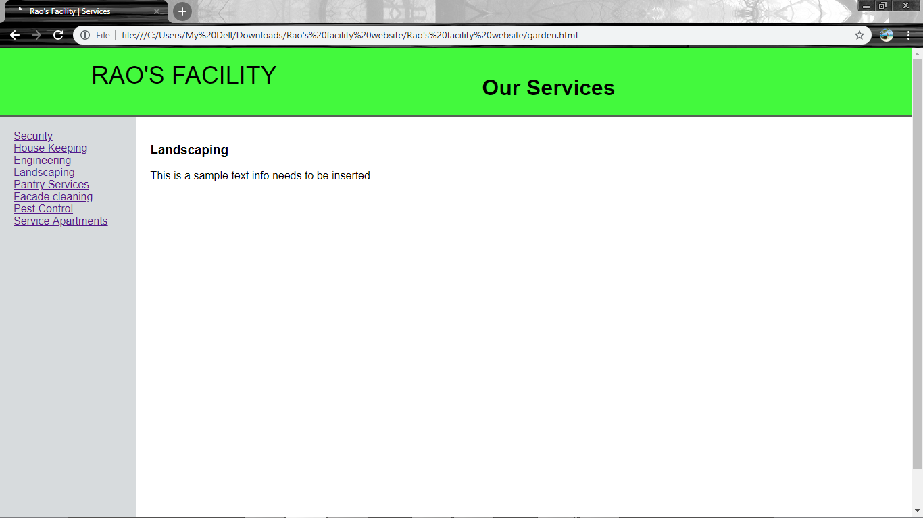

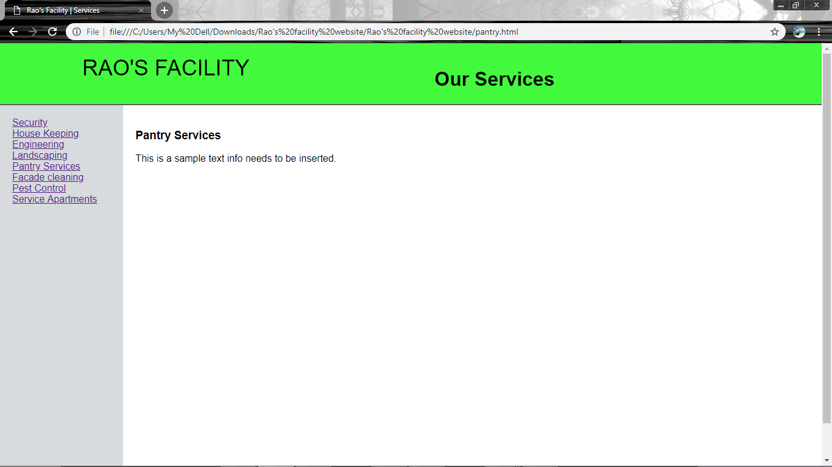

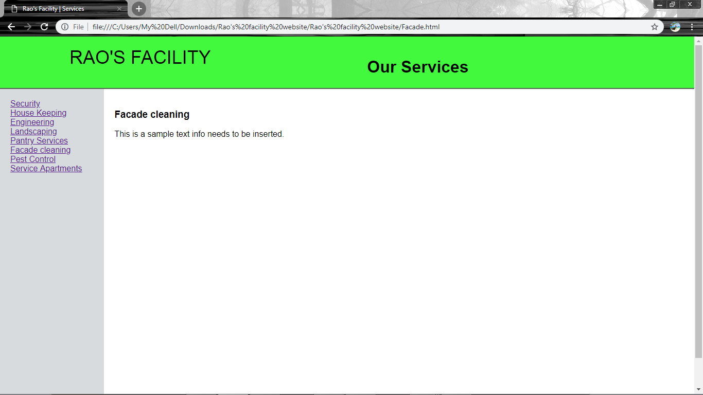

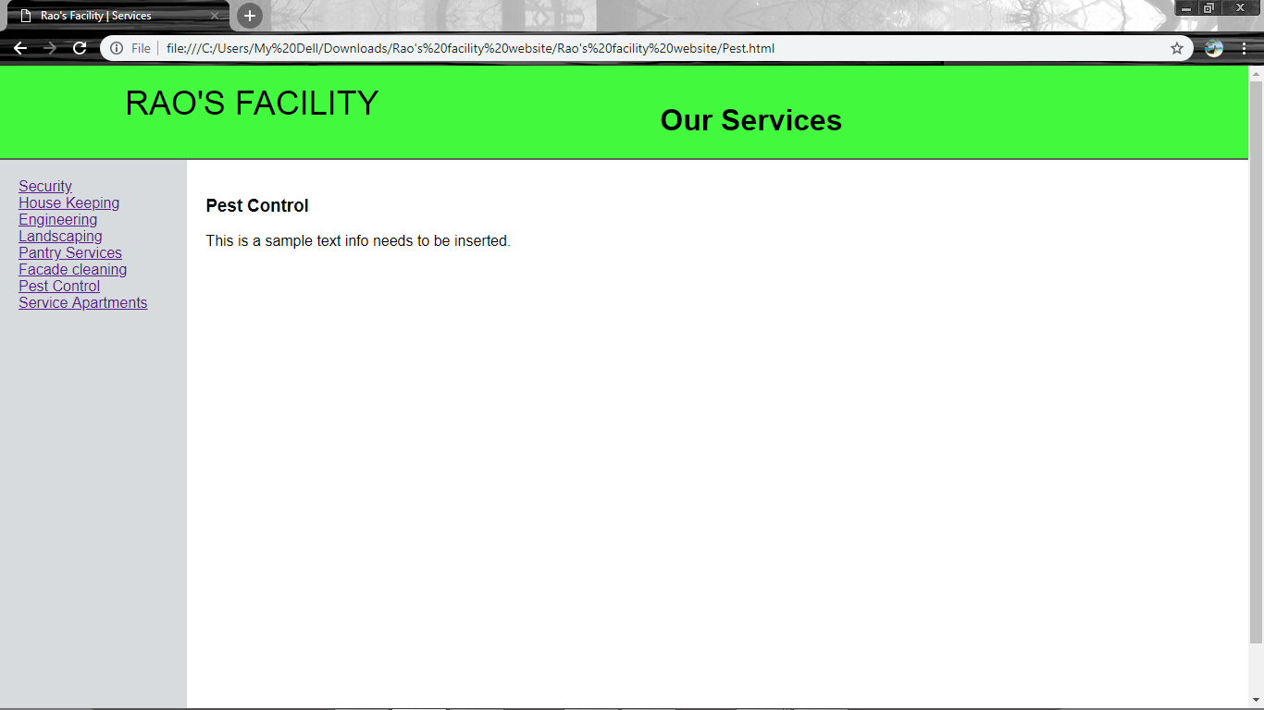

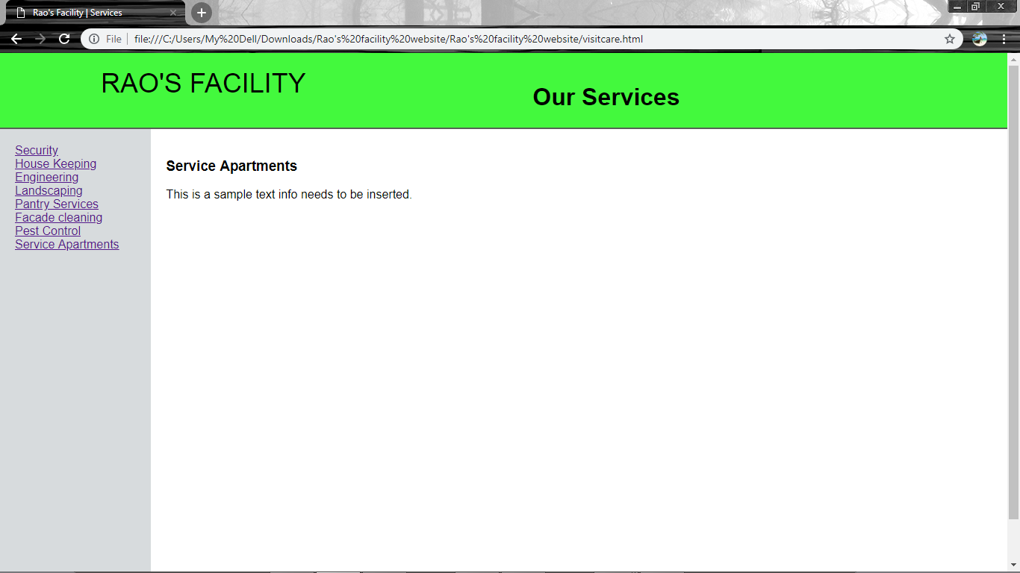

Applicability of the project

Nowadays people have become very busy and this website would be more appropriate for those people. Anyone can use this site. This product is main for the better communication between the company and customers of their company. We brought many new features to this site so that the customer should not face any problem.

Website also has a feature which is called as “Visit care” , where we can call up the company and get maids home for small works like shifting and cleaning houses. As it is going to be a technological world in future this type of connection with the customers will help this company a lot.

Coding Metrics

Login page:

LOC: 30

Complexity: 2

Lines of comment: 3

Token# : 132

Logout:

LOC: 24

Complexity: 1

Lines of comment: 3

Token# : 72

Profile:

LOC: 27

Complexity: 2

Lines of comment: 3

Token# :116

Register:

LOC: 41

Complexity: 3

Lines of comment: 3

Token# :184